**useContext**

**what is useContext?**

= useContext is a react hook to avoid the props drilling .

**What is props drilling ?**

Suppose we want to pass a data from

component1 🡪 component2 🡪 component3 🡪 component4

then we use props drilling

{id:101,name:”ibrahim chowdhury”

Component1

Component2

Props drilling

Component3

Component4

Normally we use props drilling to send data from parent to child

To avoid this props drilling we use useContext

**How we can use useContext?**

🡪1st create some file

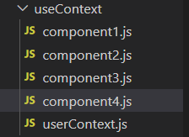

🡪In the userContext.js make the data for global,

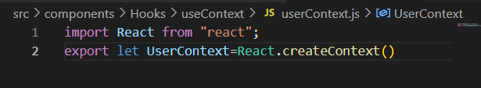

🡪 then in the component1.js write the code

import React, { useState } from 'react'

Import UserContext from userContext file

import Component2 from "./component2"

import { UserContext } from './userContext'

export default function Component1() {

    const [user, setuser] = useState({

        id:101,

Create a user data by using useState

        name:"ibrahim Chowdhury"

    });

  return (

    <div>

        <br /><br />

        <hr /><hr />

        <h3>Why we use useContext</h3>

        <p>we use useContext to avoid props drilling. Suppose we need to to send data from parent to child then we normally Props Drilling . But if we want to avoid the props drilling then we use <b>useContext</b>  </p>

<UserContext.Provider value={user}>

            <Component2/>

Make the UserContext as provider and send the data inside the value.

        </UserContext.Provider>

    </div>

  )

}

Then in component2 import and use component3 ,

import React from 'react'

import Component3 from "./component3"

export default function component2() {

  return (

    <div>

        <Component3/>

    </div>

  )

}

Then in component3 import and use component4

import React from 'react'

import Component4 from "./component4"

export default function component3() {

  return (

    <div>

        <Component4 />

    </div>

  )

}

Then In component4 import the UserContext public variable from userContext

Import UserContext from userContext

import React, { useContext } from 'react'

import { UserContext } from './userContext'

export default function Component4() {

    let user=useContext(UserContext)

Declare a variable named user and initialize it with the value return by useContext hook

  return (

    <div>

        <h5>This is how we can use useContext</h5>

        <h1>{user.id}</h1>

This is how we can access the data

        <h1>{user.name}</h1>

    </div>

  )

}